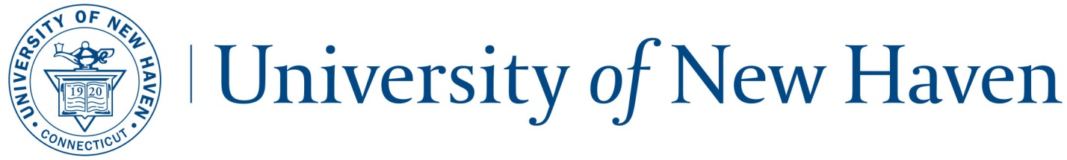
SUPERVISORS CHECKLIST
FOR ON-BOARDING NEW EMPLOYEES

About this checklist: Please review this document prior to the employee’s start date in order to prepare for the employee’s orientation. The checklist below is intended as a guideline to assist in the orientation process and may not be all inclusive of other departmental guidelines and/or objectives. Also, all items may not be applicable to all employee groups.

The orientation of the new employee should be completed within the first three days of employment.

Prior to Start Date: Administrative Procedures
Secure computer for employee, system network password and email
Obtain access to applicable network printers
Establish appropriate office/cubicle space, including pens, note pads, etc.
Request Banner access
Obtain office and file cabinet keys (if applicable)
Order business cards (if applicable)
Secure telephone and voice mail access, including instructions for voice system
Discuss with prospective employee where to park on their first day
Information regarding a parking pass and ID badge will be given to the employee during their one-on-one meeting with the HR Benefits Representative.
Day 1: Welcome to the University of New Haven
Provide organizational overview of the Department/College
Organizational chart (if available)
Introductions to key staff and colleagues within the Department
Introductions to staff outside of the Department that the employee will work with in their new position

Explain the University’s fiscal year

Brief employee on the shuttle system and parking requirements when school is in and out of session.

Provide documentation regarding the University’s phone and voice mail system

Tour of the Building
Location of office/desk/workstation
Restrooms
Kitchen/Coffee Room/Watercooler
Office supply room/cabinet
Location of printer, fax, copier, and shredder
Mail Drop (incoming and outgoing)
Location of conference rooms and emergency exits
Tour of Campus
Familiarize employee with University campus and key administrative buildings and provide campus map
Identify places on campus to have lunch or pick up food
Banner/Payroll /IT
Review pay frequency (weekly or semi-monthly); if an hourly employee, review process and requirement of submitting time
Review departmental process of requesting time in advance through Banner
Discuss supervisory pre-approval overtime process for non-exempt employees

Review on-line process of requesting assistance from IT

BenefitFocus
Encourage employee to review the Benefits Section of the HR intranet to familiarize them with benefit options, costs and plan design. Employees may not make their elections in BenefitFocus until they are made active in Banner by Human Resources and successfully complete an I-9 form.

Day 2: Safety

Review the Emergency Notification system as it relates to severe or inclement weather, including potential campus closings and class cancellations or delays.
http://www.newhaven.edu/student-life/public-safety/police/emergency-procedures.php/
Encourage employee to download LiveSafe app to their phone which provides a direct connection to the University Police Department https://mycharger.newhaven.edu/web/mycharger/livesafe-app?inheritRedirect=true

Day 3: Policy Review and Performance Expectations
Discuss your performance expectations with the employee and review the probationary period applicable to them.

Provide the employee with a copy of the probationary period form applicable to them and how frequent discussions will occur during this period to ensure appropriate progress and performance on the job. It is the responsibility of the supervisor to complete the probationary form and return the completed form to the Human Resources Department at least one week prior to the expiration date of the probationary period.

Review accessing the mycharger site, the Employee Handbook and instruct employees where all employee related policies can be found. Also, review key policies/procedures, including:

  - Sexual Misconduct Policy
  - Prohibited Relationships Policy
  - Vacation Policy
  - Appropriate Dress Policy
  - Employment-At-Will Policy (non-union employees only)
  - Smoke Free Campus Policy
Provide Overview on Annual Performance Review Process (Administrative employees only)
Time Frame of Review
Rating System
Goals

