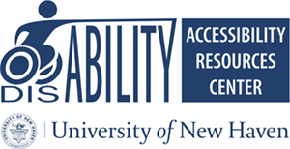

RELEASE OF CONFIDENTIAL INFORMATION
To Agency or Individual

Campus (Please check one):
West Haven Campus/ Orange Campus Tuscany Campus (Prato, Italy)

I, , authorize the Accessibility Resources Center of the university of New Haven to release information about me to the following person(s) or agency.
Name of Organization/Individual(s) _________________________________________________________________
Title __________________________________________________________________________
Address _______________________________________________________________________
City, State, Zip _________________________________________________________________
Phone Number ____________________________ Fax Number ________________________
The information to be released from my records is as follows: Documentation of my disability including, but not limited to, diagnosis and remediation.

I understand that this information shall remain strictly confidential and shall not be further relayed in any way to any other person or agency without an additional written authorization by me.

By signing this Release of confidential Information, I release the staff of Accessibility Resources Center, the University of New Haven and its employees, and the person(s) or agency named above from any liability resulting from the releases of the information. Furthermore, I understand that I may withdraw this authorization at any time prior to the release of above information. This authorizations, if not withdrawn, is valid until or until canceled by me in written. This release form has been read/reviewed with me and I understand its content.

Student Signature: ___________________________ Date: ________________________________

Witness Signature: ___________________________ Date: ________________________________

Release of Confidential Information to Agency 3.6.20

